AI-VET kit possibilities

DEVICE | IMAGE | PRICE (APROX.)
Motor DRIVER L298N  (or similar) | 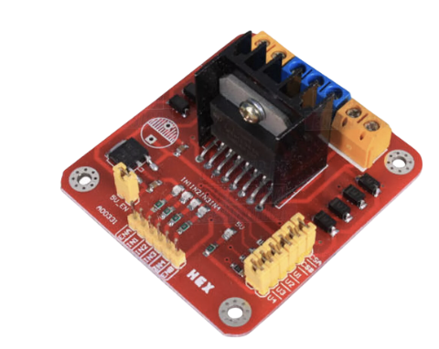 | 9
KIT 2WD CHASSIS | 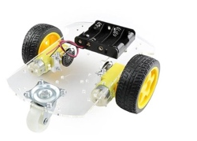 | 12
RASPBERRY PI 5 - 8BG | 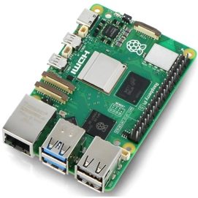 | 100
NVIDIA JETSON NANO QUAD-CORE 4GB DEVELOPER KIT | 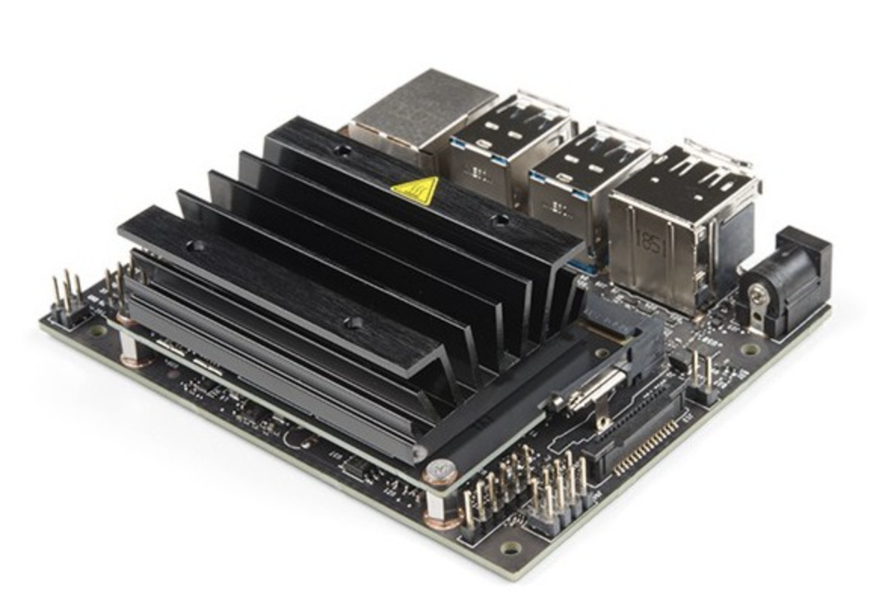 | 220
Camara RASPBERRY PI V2 8MP 1080P | 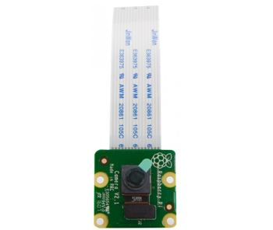 | 29€
Camara V3 oficial Raspberry Pi - 12MP 120° - Raspberry Pi Camera Module 3 Wide | 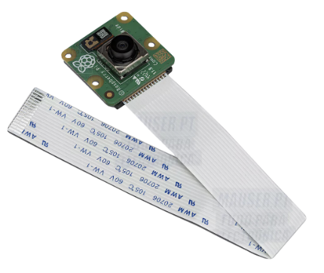 | 41€
MICRO SDXC 64GB U3 CLASS 10 V30 ADATA with  SD adapter | 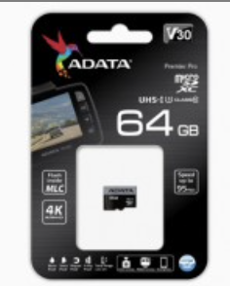 | 16€
Other sensors /actuators | To be defined
Cables, wires and boxes | To be defined

Issues
- Cost of the kit
  - Quality versus quantity
  - What are VET schools more familiar?
- Final composition
  - Comparative study
- Hat creation (to make easier the assembly/expansion)
- Terms of acquisition

